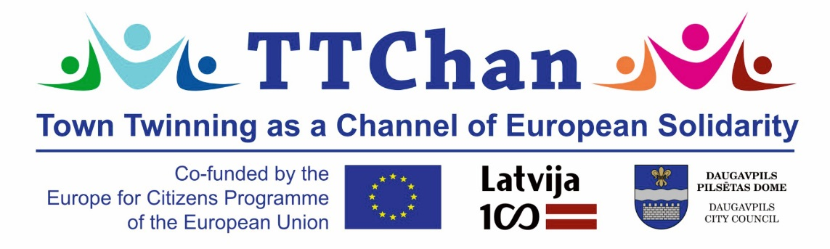

**Daugavpils City Council has implemented the project “Town Twinning as a Channel of European Solidarity” TTChan**

Daugavpils City Council, as a lead partner, together with project partners from different EU countries and cities, has implemented the TTChan project in the framework of the measure “Town Twinning” of Action 2 “Democratic Engagement and Civic Participation” of the European Union programme “Europe for Citizens”. The project involved 6 partners from 6 countries: Lithuania, Poland, Germany, Sweden, Serbia and Latvia; in the frameworks of this project partners from Italy visited Daugavpils as well. The aim of the project was to strengthen town twinning through democratic engagement and civic participation based on sharing, understanding, solidarity and intercultural synergy for better future of Europe.

Daugavpils City Council as a lead partner organized international meeting in Daugavpils on 8th – 12th November, 2018. All partners were invited to visit Daugavpils to get acquainted with local culture, to share experience, to get prepared to celebrate Latvia Centenary, to visit Daugavpils and Latgale region tourism places and objects.

On the first day, project partners arrived in Riga, where they had the opportunity to see the old town. Later representatives of Daugavpils City Council introduced everyone to the facts about Daugavpils and Latvia, and there was an opportunity to learn a few words in the Latvian language. The organizational details for the TTChan project were discussed in brief.

The second day was the project's launch day, which began with an official meeting in Daugavpils City Council, where a presentation about Daugavpils was shown and partners presented their cities and countries. The city of Raška in Serbia concluded a Memorandum on cooperation with the city of Daugavpils in Latvia. The meeting continued at Daugavpils University, where project partners and all interested inhabitants of Daugavpils and Latgale could get acquainted with the ideas, activities and planned outcomes of the TTChan project; each partner shared their good practice examples of how they promote solidarity and intercultural synergy in their cities and countries. All project partners gave express-interviews, which will be available on the project's Facebook page. Everyone was introduced to the essence of the Centenary of Latvia, presented by the representative of the Ministry of Culture. This was followed by a lecture “Daugavpils democratic engagement and civic participation in European context” under the guidance of a lecturer at Daugavpils University. All participants were actively involved in the debate on the future of Europe and understanding Euroscepticism. The session ended with group work, where participants had the opportunity to share their vision on the future of Europe, the attitude to Euroscepticism, and how to promote the topic of their city or country. In the afternoon, everyone was able to participate in the red-and-white ribbon folding event in the Daugavpils Regional Studies and Art Museum. In the evening, international partners visited Daugavpils fortress and Daugavpils Mark Rothko Art Centre. Dinner was devoted to intercultural presentations, in which Daugavpils was presented with Latvian and Latgalian songs and dances. The project partners presented their cities and countries in different ways – showing their national costumes, dances, songs, telling stories and introducing to national music.

On the third day of the project, everyone had the opportunity to get acquainted with the traditions, places and objects in Latgale. The Naujene castle mound and ruins of Dinaburg castle, Vasargelišķi sightseeing tower, Krāslava town and castle, Aglona Basilica and the Aglona Bread Museum were visited in the Latgale region. In general, everyone got acquainted with Latgale tourism objects, history, culture, traditions, culinary heritage, and local people who are proud of being Latvians and Latgalians.

On the fourth day, the participants of the project had an opportunity to get acquainted with the Daugavpils School of Design and Art “Saules skola”. All together actively shared their thoughts on the importance of the program “Europe for Citizens” in fostering town twinning and cooperation. Working in national work groups, the participants developed a special offer – what events can be visited, what can be seen and what each city is most proud of; the summary of this work group will be supplemented and published on all the partners' websites as well as on the project's Facebook page. At the end, there was an opportunity to get acquainted with the history of Latvia from its foundation to the present day.

The evening event was a central patriotic event throughout the project – it was a torchlight procession to celebrate Lāčplēsis Day. It was very important for project organizers to promote patriotism, to raise awareness about historical events and to create a sense of belonging to all those involved in the project. The partners acknowledged that they felt as locals, as the torchlight procession was unifying and emotionally exciting, the participants admired the patriotism spirit of Daugavpils and pride about the country and traditions. November is a patriotic month in Latvia, as November 18 marks the birthday of Latvia. The events of Lāčplēsis Day are traditionally taking place in Daugavpils with a wide and diverse program. The torchlight procession has become one of the most beautiful traditions in recent years, as it involves several thousand participants.

The last day was emotionally rich. Everyone wanted to speak about their experience, about the new knowledge, about the new potential partners and the areas in which cooperation will follow. The project's strengths and nuances, which could be improved in future cooperation projects, were evaluated. The directions for future cooperation with the same partners were discussed. It was a pity to say farewell because in five days the cooperation partners had become friends. Thus, the project's aim and planned outcomes were achieved.

The EU program “Europe for Citizens” aims to bring Europe closer to its citizens by stimulating the debate on topical issues of the European Union at local, regional and international level. It is essential to create conditions that enable citizens to participate in the European Union policy-making processes, to strengthen solidarity among European citizens, and to ensure that civil society organizations, their members and any member of society are involved in the democratic life of the European Union.

The project is financed under the programme „Europe for Citizens”. Implementation term: 08/11/2018 – 12/11/2018.

More information on the project can be found on Daugavpils homepage:

<https://www.daugavpils.lv/pilseta/pilsetas-attistiba/projekti/istenotie-projekti/2014-2020-gada-planosanas-periods/>

And, on project’s TTChan Facebook page: <https://www.facebook.com/ttchandaugavpils/>

*Information prepared by Development department*